It 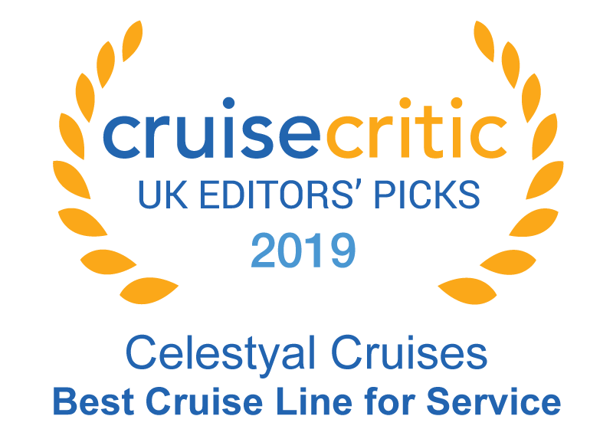

**FOR IMMEDIATE RELEASE**

**CELESTYAL CRUISES LAUNCHES WEEKLY DEALS OFFERING DISCOUNTED RATES,**

**LOW DEPOSITS AND FLEXIBLE BOOKING TERMS ON 2021 SAILINGS**

ATHENS, GREECE (February 02, 2021) – [Celestyal Cruises](https://celestyal.com/us/), the award-winning, number one choice for cruise travelers to the Greek Islands and the Eastern Mediterranean, launches a series of **seven-day** [**Flash Sales**](https://celestyal.com/us/deal-of-the-week/) that vary in value, starting from as low as $729 per person, based on double occupancy, on qualifying 2021 seven-night cruises. The Flash Sale also features a lower deposit of just $99 per stateroom. For ultimate flexibility and in order for guests to have peace of mind, the Flash Sale also includes the “Celestyal Promise,” allowing guests the freedom to adjust their sailing up to 30 days prior to departure.

Each Flash Sale will run for a seven-day booking period starting on midnight every Thursday. The next Flash Sale runs from February 5th to the 11th of February and will feature selected seven-night sailings. Flash Sales will continue each Thursday through March 26th. The attractive, value for money deals, feature discounted rates on qualifying 2021 itineraries and a variety of departure dates on the three- and four-night Iconic Aegean and Discovery Aegean, the seven-night Idyllic Aegean, Eclectic Aegean, Three Continents and Steps of St Paul as well as fourteen-night cruises.

All cruises include the [Celestyal All-Inclusive Experience](https://celestyal.com/us/whats-included/) with unlimited classic drinks, locally-inspired cuisine on-board, entertainment, select shore excursions, port service charges and gratuities.

For more information or to book visit: <https://celestyal.com/us/>

###

**Media Contacts:**

Charles Mardiks, Mardiks PR, [chuck@mardikspr.com](mailto:chuck@mardikspr.com), ph: +1.646.283.5273

Frosso Zaroulea, Celestyal Cruises, [f.zaroulea@celestyal.com](mailto:f.zaroulea@celestyal.com), ph:+30.216.4009659

**About Celestyal Cruises**

Celestyal Cruises has fast built an award-winning reputation and recognition as the number one choice for cruise travellers to the Greek Islands and East Mediterranean thanks to its regional expertise and exceptional hospitality. The company operates three vessels, each one intimate enough to provide genuine and highly personalised services. The foundation of the company’s philosophy is built on a unique Greek heritage which combines outstanding hospitality with genuine cultural destination immersion and provides authentic, lifetime experiences both onboard and onshore.

**Awards**

In September 2020, Celestyal Cruises was honored for the second consecutive year at the renowned **MedCruises Awards.** The company was awarded first place in the category "Cruise Line with the Greatest Solidarity and Commitment during the Pandemic,” for its overall contribution to the local community, as well as to the industry as a whole, in light of the addition of a new vessel to its fleet during this critical period. In June 2020, Celestyal Cruises received three Tourism Awards in the largest and most prestigious competition for the Greek tourism industry. For the seventh consecutive year, Celestyal Cruises took top honors with three Tourism Awards: Platinum Award for Guest Experience Excellence, Gold Award for Familiarisation Initiatives for Special International Target Groups and Silver Award for Solo Travel.

In February 2020, Celestyal Cruises was honoured at the Cruise Excellence Awards for its "Three Continents" cruise, as the best cruise itinerary for 2019.  In June 2019, Celestyal Cruises was recognised for its overall contribution and commitment to the development of the cruise industry in the Eastern Mediterranean region at the MedCruise Awards in Genoa. In December 2019 and 2018 respectively Celestyal Cruises received the U.K. Editors’ Picks Award for Best Service by Cruise Critic, the world's largest cruise review site and online cruise community. In February 2018 Celestyal Cruises received four Cruise Critic Cruisers’ Choice Awards: two first place awards, for Shore Excursions and Value, and two second place awards, for Service and Entertainment.

**Corporate Responsibility**

Celestyal Cruises is deeply committed to sustainability and ethical business practices. The company actively supports the local communities in the destinations it visits, particularly in the field of education. Since 2015, more than 2000 students on the Greek islands of Milos, Patmos, Samos and Ios have enjoyed a ‘journey to knowledge’, by attending specialised educational programmes, initiated by Celestyal Cruises. Additionally, Celestyal Cruises supports cultural NGOs to promote youth entrepreneurship, marine student development and child welfare.

**ISO Certification**

The entire spectrum of Celestyal Cruises’ ship management, including technical, hotel and crew management, and offices, are certified in accordance with ISO 9001/14001 standards. The certifying authority is DNV-GL, which is by widely recognised as the biggest and most respected rating agency in the marine industry.

**Follow us at:**

[**Facebook**](https://www.facebook.com/CelestyalCruisesGreece)**,** [**Instagram**](https://www.instagram.com/celestyalcruises/)**,** [**Twitter**](https://twitter.com/celestyalcruise)**,** [**LinkedIn**](https://www.linkedin.com/company-beta/9176465/)

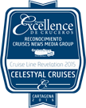 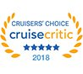 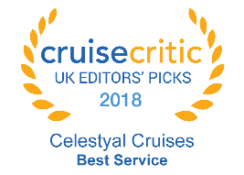  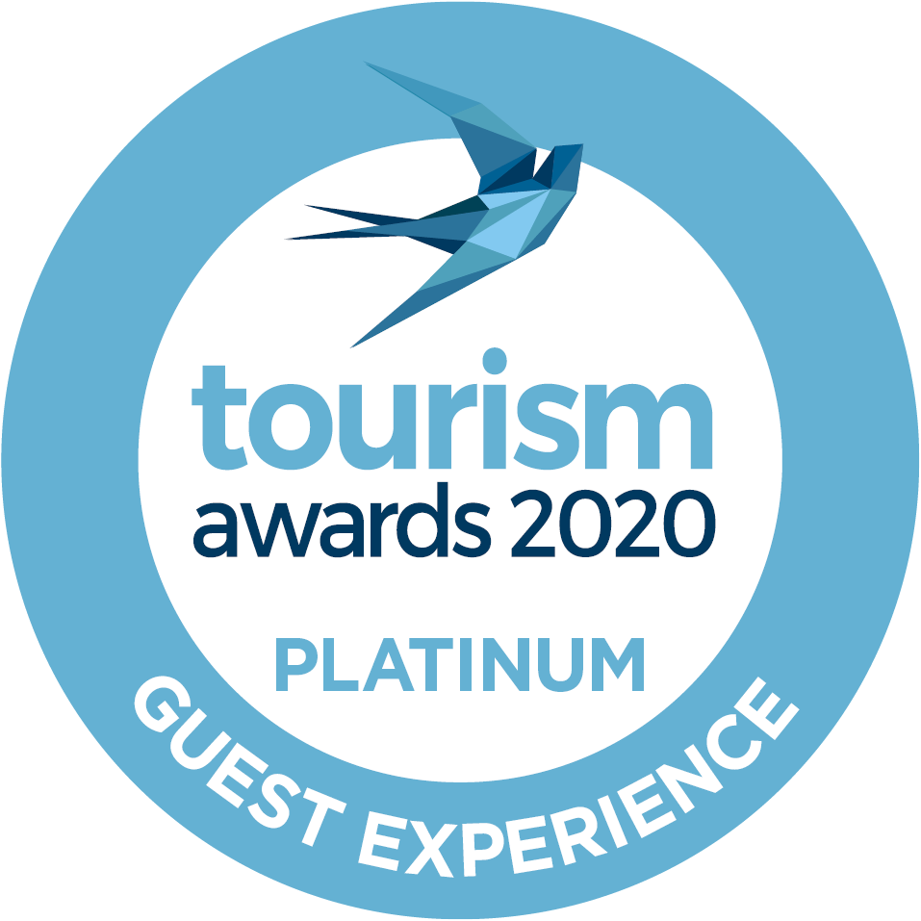 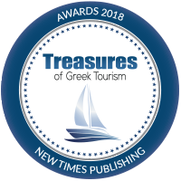 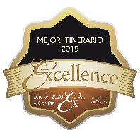

***Member of*** 